Summary on Week 6 Mini Project
Section A: LLM Foundations & Hugging Face
1.Hugging Face Setup & Text Generation
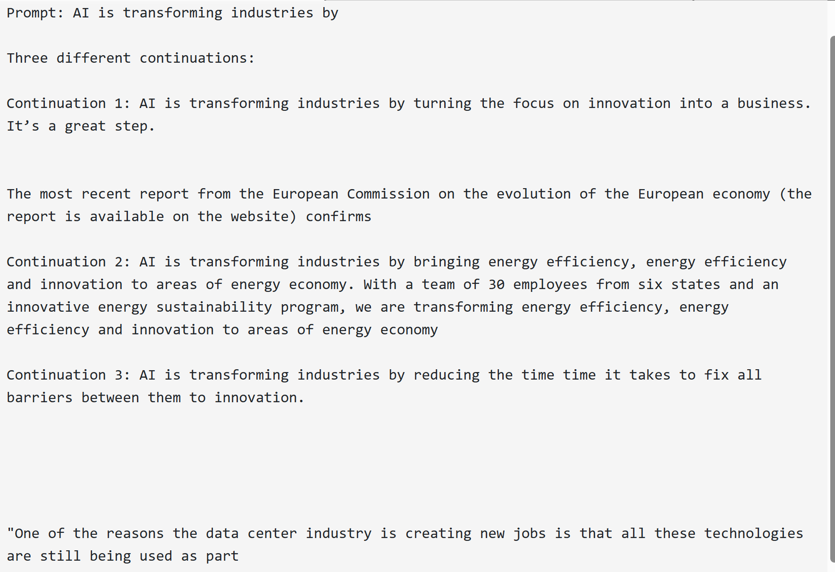
The output shows 3 different continuations of the given sentence. We have used Hugging face transformers with the model ‘distilgpt2’ to generate these texts.
‘Distilgpt2’ mainly provides texts as the continuation of previous texts. So we have provided the given text to create the continuations to it.

2.Tokenization Demo
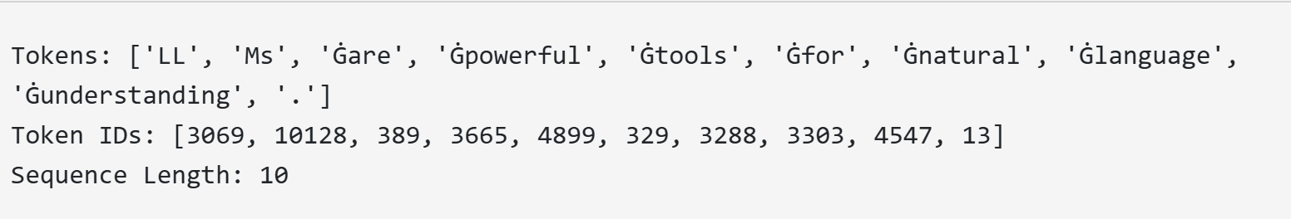
For the tokenization, we have used the provided sentence "LLMs are powerful tools for natural language understanding.” To create the tokens.
Tokenisation is nothing but converting human language (text) into numbers that a model can understand.
A sentence can be divided into smaller meaningful words or subwords called tokens as shown in the above picture.
The output Tokens contains G at the starting of each token because we have used ‘Distilgpt2’ model to create the tokens and G means space before the word in Distilgpt2.
TokenIDs are the numerical representations of tokens created using ‘tokenizer’ of Transformers.
Section B: Prompt Engineering - Summarization
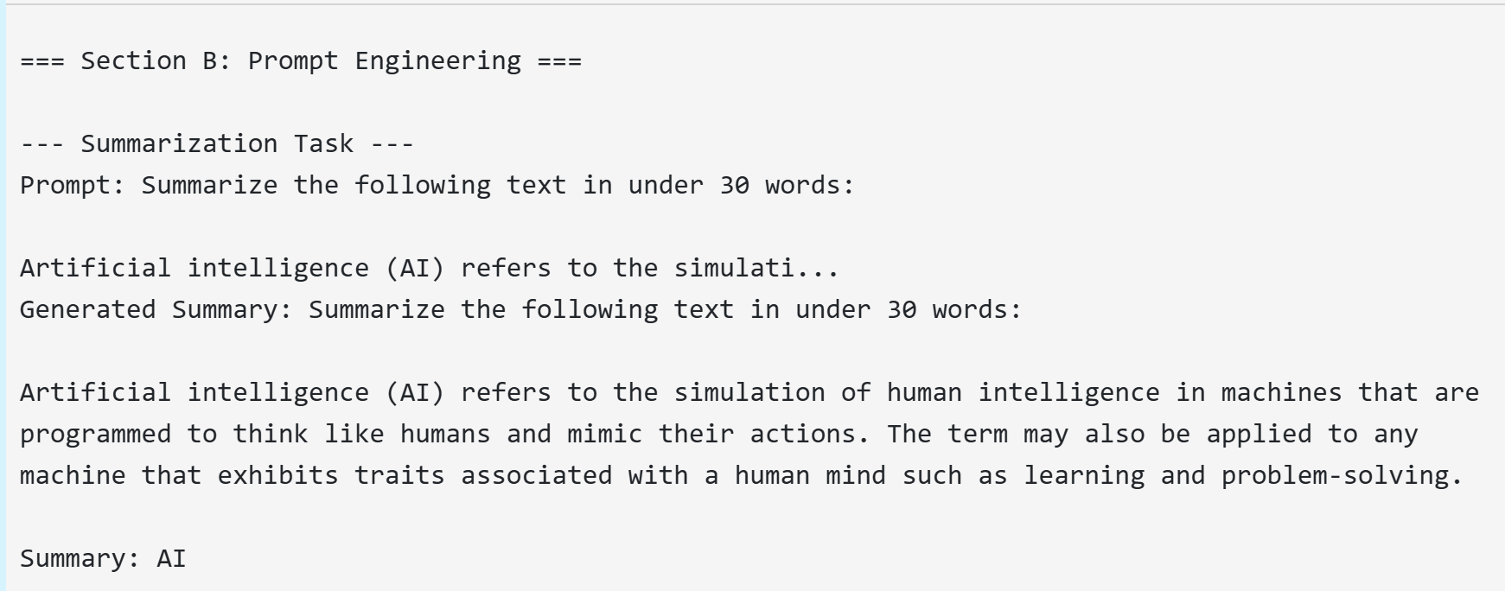
In this prompt Engineering Summary generation task, what I have observed is that, whatever the length we have mentioned in the prompt, the models only writes the sentences based on the length we have given in our code i.e, max_length=30.
When I have given max_length=150, it has generated the summary with few sentences, generated output repeated parts of the input text and included additional unrelated information instead of producing a concise summary eventhough when we mentioned to provide text under 30words, but when given max_lenght=30, it stopped at ‘AI’.
Even if we write a very clear prompt, the model only performs according the values we have provided in the code.
Q&A and Creative Text Generation
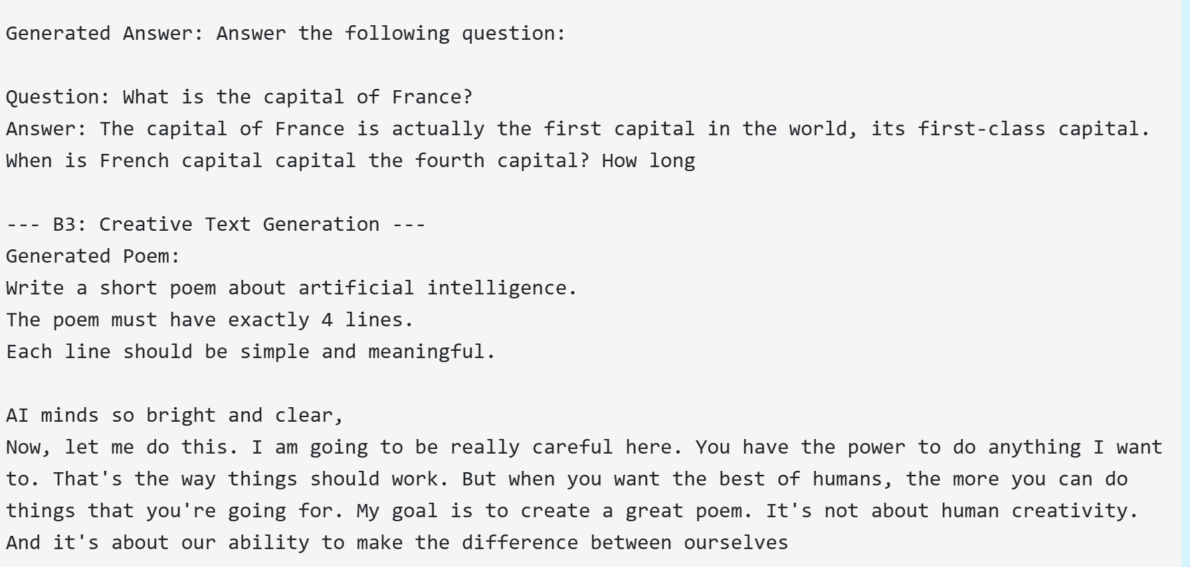
The Q&A and Creative Text generation parts was quiet frustrating because the outputs were not related to the prompts we are giving.
When we have given the question to answer the capital of France, it generated a long text but not the actual answer which is paris.
I have tried changing the max_length of the sentence to 10 thinking that would give me the correct result. But that’s of no use as we are using the ‘Distilgpt2’ model.
Distilgpt2 model don’t focus on strict instruction but focuses on the text generation and sentence continuation, it predicts the most probable next tokens rather than thinking about correctness.
It is very important to use the models that works by following the instructions on the given prompt rather than just focusing on sentence continuation.
Creative text
Creative text is also failed just because of using Distilgpt2 model. This model don’t focus on strict instructions but focuses on text completion. So it generated the text without thinking of the poetic structure.
I came to know that it is very very important to use the perfect models that satisfy our needs.
Section c: Embeddings with Gensim- Word Embeddings
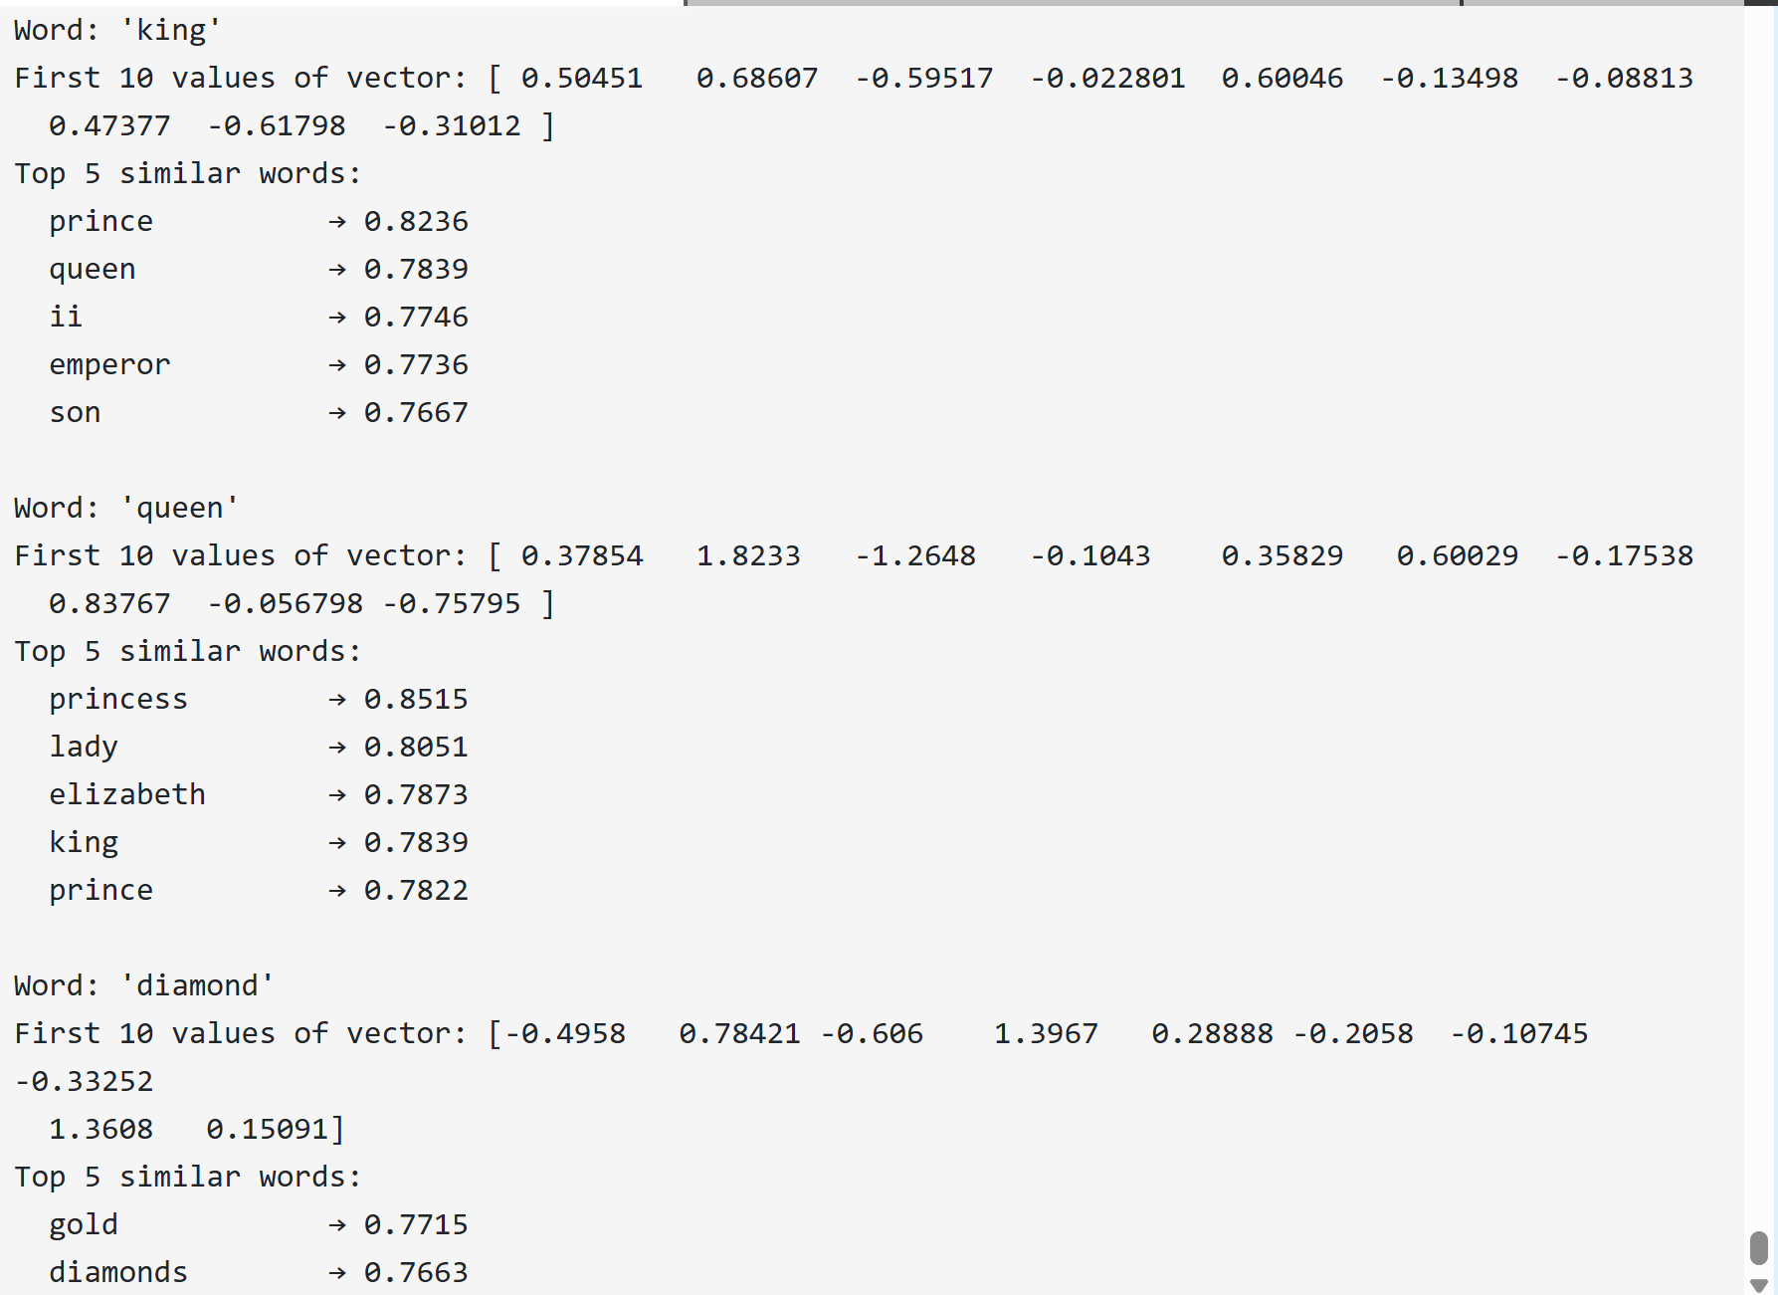
Embeddings are numerical representations of text or sentences that capture meaning. Embeddings convert words into vector(list of numbers) so that the computer can understand the relationships easily.
Gensim is a Python library used to understand text by converting words and documents into meaningful numbers (embeddings).
Genism is particularly used for Embeddings, similarity and vector search. I checks the similarity between words like when a word is given, it generates its related words as shown in the about output.
We have used the pretrained model "glove-wiki-gigaword-50" to create the glove vectors, the vector representations of words, When the most_similar() function is used, Gensim internally compares the vector of a given word with vectors of all other words in the vocabulary. Even though cosine similarity is not explicitly written in the code, it is used behind the scenes to measure how close the meanings of words are.
Based on this similarity calculation, Gensim returns the top five words that are most semantically similar. This is why words like king return related terms such as queen and prince, showing that embeddings successfully capture real-world relationships between words.

Sentence-Level Embeddings
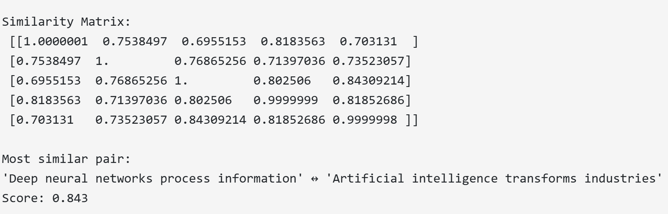
Here we have use Cosine_similarity explicitly to create word embeddings and create the similarity matrix.
Cosine similarity is a way to measure how similar two vectors are. Its basically used to find text similarity.
For every sentence each word is converted into vector and an average of those vectors was calculated so that for each sentence a vector is created. This is called sentence embedding.
Sentence embedding is nothing but a vector(numerical) representation of a sentence.
Once we have sentence embedding we can calculate the similarity between the sentences as similar vector values can be a result to similar sentences. This similarity is calculate using cosine similarity.
The similarity matrix for the sentences have been generated, the most similar sentences are displayed with the similarity score.

Section D: Application Exploration
Transformer Application
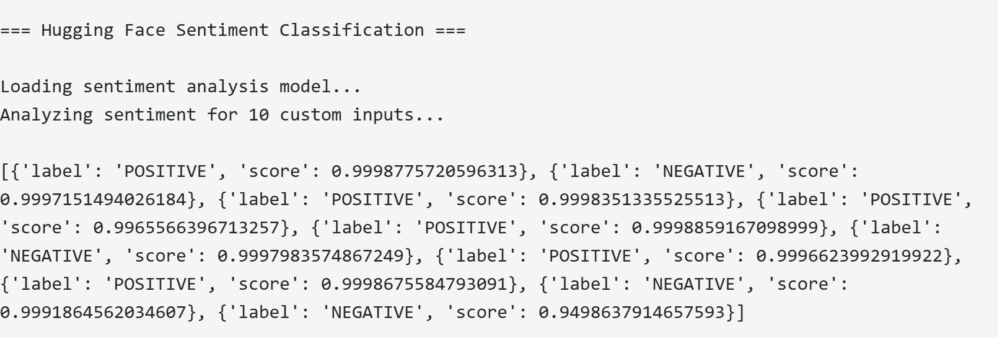
I have used the Hugging Face Transformer Pipeline to define the sentiment of the statements, I took 10 statements to check their sentiment.
We have used the ‘sentiment-analysis’ a special alias in Hugging face to check the sentiment of the statements.
We have used the predefined model “distilbert-base-uncased-finetuned-sst-2-english".
Hugging Face Transformers have made it easy to calculate the sentiment of sentences by just simply providing the predefined functions. We can easily summarise, translate, classify the sentences using the simple commands only. This makes the transformers very user friendly and easy to work with.

Key observations about LLMs vs. embeddings:
LLMs and Embeddings play a very different role while working with text. LLMs will create a new text every time we run while the embeddings will create the same numerical values for every run.
LLMs are basically used to generate text, write summaries, answer questions, write creative content like poems and stories where as Embeddings will represent the meaning of the sentences in numerical form known as vectors.
LLMs basically understand and generate the human like text by predicting the next word based on the context provided while Embeddings on the other hand don’t ever create a new text, they just work on the given test. Embeddings generates the mathematical representations of words and used calculate the similarity between the sentences using the vector representations and cosine similarity.
LLMs help the machines to communicate the meaning while Embeddings help them to understand the meaning.

Applications of Vector Search & Embeddings:
- Semantic Search : is used to find documents or content based on the context
- Recommendation Systems: Suggest similar items
- Duplicate Detection : Spot repeated content
- Chatbots & Virtual Assistants → Retrieve relevant info before generating answers
- Sentiment Analysis → Group feedback by meaning
- Fraud Detection → Identify risky patterns
- Question-Answer Systems → Quickly find answers in large datasets

This mini project has shown how LLM can generate different types of texts based on the given scenarios. It is much useful in Prompt Engineering but using the good model can result in correct outputs. Embeddings take the NLP to next level by using things like cosine similarity and calculating the similarity between the sentences. This makes it easy to compare the sentences or find related content efficiently. Together, LLMs and embeddings complement each other, enabling smarter and more flexible AI applications.

